PREREQUISTIES:

IBM IOT CLOUT CREATION:

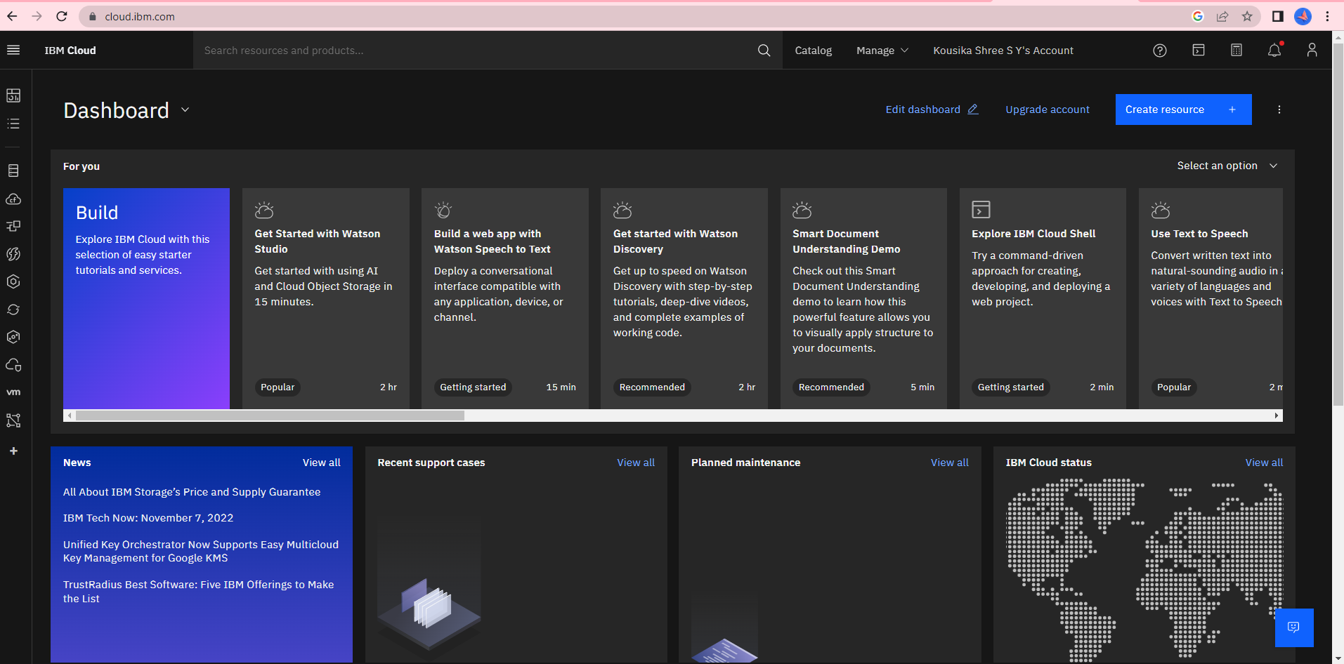

SOFTWARE:

